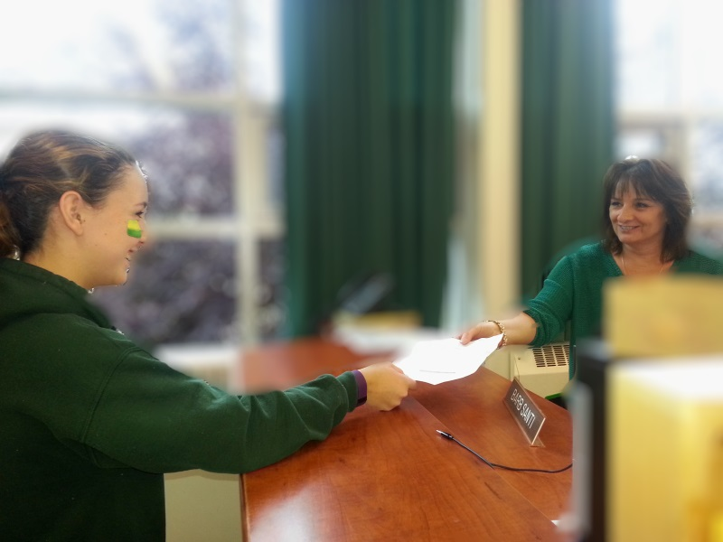

|  |  |
| --- | --- |
| Name of University | Title of Program |
| 1. |  |
| 2. |  |
| 3. |  |
| 4. | Extra Fees Apply ($50.00) |
| 5. | Extra Fees Apply ($50.00) |

The earliest date an Ontario high school student may be required to respond to an Ontario university’s offer of admission and give a financial commitment.

(e.g., registration deposit, residence deposit, etc.).

## June 3rd, 2019

## May 29th, 2019

The latest date all high school applicants can expect a response from an Ontario university. This includes: an offer of admission, a refusal, or a deferral, once additional information is received.

## Application Deadline:

November 29th–December 5th, 2018. Completed in Lockerby’s Library

## Applying Online:

January 16th, 2019

Apply on or before this date in order to receive equal consideration for admission to programs starting in the fall of 2018. After this date, universities consider applicants on a first-come, first-served basis until programs are full.

Dates

Important

# **University Applications For Fall 2018**

Review the Newly Revised Website:

[www.electronicinfo.ca](http://www.electronicinfo.ca)

At the **e-info site**, review –

***Applications - What You Need to Know.***

Students should be familiar with dates, terminology and unique programs such as the collaborative university and college programs.

Additional information can be reviewed using the Ontario University Application Center’s (OUAC) website.

<http://www.ouac.on.ca/ouac-101/101-admreqs/>

Students will receive individual pins in order to complete their applications. Students will register using a 101 Application Form at [www.ouac.on.ca](http://www.ouac.on.ca)

**Registration Fees:**

The basic application fee is $150.00. This fee covers 3 choices. Additional choices can be selected at a cost of $50.00 per choice. Note: students will be charged a fee of $50.00 for any changes that they complete after the applications have been submitted.

**Registration Sessions:**

Students are required to sign up for a session in Guidance from Nov. 19th – Nov. 23rd, 2018.The sessions will occur in our school’s library from Nov. 29th – Dec. 5th, 2018.

Students should come to the registration session prepared and on time. Sessions will run three periods a day.

**Planning Ahead:**

Please use the chart below to identify your post-secondary choices. Bring this document with you to your registration session.

The easiest method for payment is a credit card. Students will need to have the name on the credit card, the card’s number, expiry date, and the CSC number on the back.

**Information Events:**

**University Information Evening:**

21 Ontario Universities will be at Lockerby on October 18th, 2018 from 7:00 – 9:00 pm

**Ontario University Fair:**

Metro Toronto Convention Center Sept. 28 -30, 2018 from 10:00 am – 5:00 pm

# **Before you attend your university registration session, ensure you have completed the following:**